Max Shi  
CH 362  
Professor Attygalle  
I pledge my honor that I have abided by the Stevens Honor System.

**1) Title of Experiment:**

Classification of Organic Materials with, Quantitative Determination by, and Comparison of Different Solvents in Fourier Transform-Infrared Spectroscopy

Date: October 17, 2020  
Name of Technique: FT-IR Spectroscopy

**2) Technique:**

Fourier Transform-Infrared Spectroscopy is a technique used for both determination of the concentration of a compound in solution and determination of the identity of a compound. The former can be done in similar ways to UV-vis spectroscopy, where an absorbance plot at the maximum absorbance wavelength combined with Beer’s Law can be used to extrapolate the concentration of a substance given calibration solutions. The latter is done by plotting the absorbance over different wavelengths in the infrared spectrum. Bonds in organic molecules, when hit with infrared light, absorb at certain wavelengths to vibrate or stretch. Thus, because different organic molecules have different bonding, their infrared spectrum absorbance plot will be unique to the molecule, and the identity of unknown molecules can be determined. FT-IR spectroscopy can be used in many different ways to analyze compounds of different states of matter, including solids, liquids, gases, and solutions.

The setup for this experiment involves using a Perkin Elmer Spectrum Two device, which uses the basic setup of transmitting an IR wave through a sample, and then measuring the absorbance through an IR detector at the other end of the beam. Thus, the infrared absorption spectrum is generated. The sample is loaded differently into the machine depending on the method used, which will be detailed throughout the experiment.

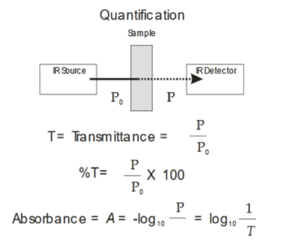

Figure 1: Diagram of FT-IR Spectroscopy Setup

**3) Application of the Technique to my Experiment**

The first part of this experiment involves using a technique called Horizontal Attenuated Total Reflectance to characterize different materials using FT-IR. Horizontal Attenuated Total Reflectance is technique that involves placing a sample as a thin film against a crystal of high reflective index, and having an IR beam shined on the combination at an angle. The sample then absorbs some of the IR beam and the attenuated IR beam is reflected toward the machine’s detector, allowing for an infrared absorption spectrum to be generated. This can be seen in more detail in Figure 2.

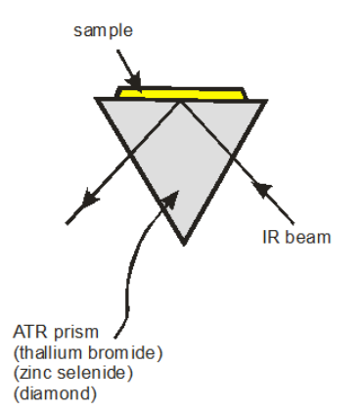

Figure 2: FT-IR Spectroscopy Setup with Horizontal Attenuated Total Reflectance

In this portion of the experiment, the infrared absorption spectrum of various organic plastics (PETE, HDPE, LDPE, PP, PS) will be measured, as well as the spectrums of three unknowns, a soda bottle, the inner lining from an aluminum can, and a completely unknown sample. By interpreting each known spectrum and comparing the peaks to the unknowns, the unknown samples will be able to be classified as one of the known organic plastics.

The second portion of this experiment involves the characterization of different liquid organic compounds. This involves loading the samples in solution into a demountable NaCl cell, as seen in figure 3, with the sample fill and sample out holes in the apparatus. In this experiment, the samples will be in a chloroform (CHCl3) solution. After taking and classifying the infrared spectra of cyclohexane, ethyl acetate, and methyl ethyl ketone, an unknown will be given. The infrared spectrum of the unknown solution will be compared to the three known solutions, and the identity of the unknown solution will be identified.

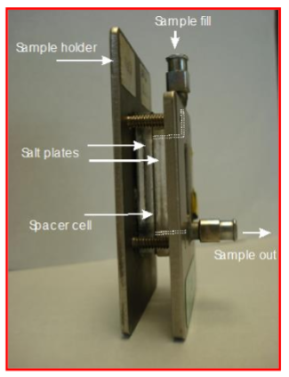

Figure 3: NaCl Cell for FT-IR Spectroscopy

The third part of this experiment is the determination of the concentration of a solution of methyl ethyl ketone by using the standard linear calibration method. Five standard solutions of different concentrations will be given. The NaCl cell will have a 0.2 mm gap to standardize the path length of the IR beam. To fill the cell, a glass syringe and a steel needle will be used. The trials will be done in increasing concentration order, and after each trial, the cell will be cleaned with organic solvent and the next solution. After each absorption spectra has been recorded, a peak can be identified that varies with concentration. Then, using that frequency, absorbance values of each sample can be measured, and the calibration plot can be created. Thus, standard ordinary linear calibration can be carried out with the unknown to recover the concentration.

The final part of the experiment is to compare the results of using of two different solvents for solid particles. In this experiment, solid benzoic acid will be analyzed with the two different methods. The first method is the pellet method, where the solid sample, crushed, is mixed with dry KBr and ground further, then compressed into a disc. To create the pellet, the sample must be loaded into the pellet creating apparatus and pressed, according to figure 4. Using this pellet, the FT-IR spectrum can be taken of this compound. The second method involves mixing the solid sample with Nujol (a type of mineral oil) and grinding the mixture into a paste. After a small amount of this paste is placed between two NaCl plates, and the FT-IR spectrum can be taken. After both spectra are obtained, the differences between the two will be compared.

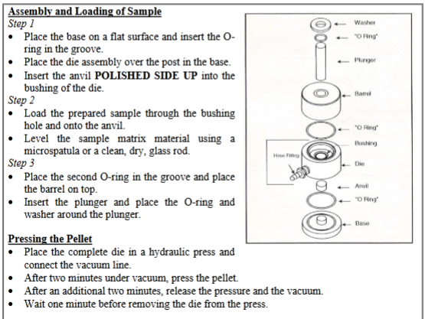

Figure 4: Setup and Usage of Pellet Press Apparatus

**4) Calculations:**

There are no necessary pre-lab calculations for this lab.

**5) References:**

1. Attygalle, A. Instrumental Analysis I Lecture and Laboratory Manual <https://sit.instructure.com/courses/38802/files/6982711?module_item_id=1042514> (accessed Oct 11, 2020).
2. Harris, D. C. *Quantitative Chemical Analysis*, 8th ed.; W.H. Freeman and Co: New York, 2010. Chapter 19.

**6) MSDS:**

**Cyclohexane**

CAS No.: 110-82-7  
Molecular Weight: 84.15  
Chemical Formula: C6H12  
Appearance: colorless liquid  
Lab Protective Equipment: Lab coat, goggles  
Highly flammable liquid and vapor.

**Health effects:**Causes skin and eye irritation, may cause drowsiness or dizziness, may be fatal if swallowed and enters airways.

**First Aid measures:**Eye contact: rinse immediately with water, especially under eyelids, for >15 minutes. Get medical attention.  
Skin contact: wash off immediately with plenty of water and soap for >15 minutes. Obtain medical attention.  
Inhalation: Move to fresh air. If breathing if difficult, give oxygen. If not breathing, give artificial respiration with a one-way valve. Get medical attention immediately if symptoms occur.  
Ingestion: Do not induce vomiting. Aspiration hazard. Call a physician or poison control center immediately.

**Other hazards:**Fire: highly flammable vapor and liquid.  
Explosion: vapors may form explosive mixtures with air.

**Ethyl Acetate**

CAS No.: 141-78-6  
Molecular Weight: 88.11  
Chemical Formula: C4H8O2  
Appearance: colorless liquid  
Lab Protective Equipment: Lab coat, goggles  
Highly flammable liquid and vapor.

**Health effects:**Causes skin and eye irritation, may cause irritation of digestive and respiratory tract.

**First Aid measures:**Eye contact: rinse immediately with water, especially under eyelids, for >15 minutes. Get medical attention.  
Skin contact: wash off immediately with plenty of water for >15 minutes. Remove contaminated clothing. Obtain medical attention.  
Inhalation: Move to fresh air. If breathing if difficult, give oxygen. If not breathing, give artificial respiration. Get medical attention immediately if symptoms occur.  
Ingestion: Do not induce vomiting. Do not give anything by mouth to an unconscious person. Get medical aid.

**Other hazards:**Fire: highly flammable vapor and liquid.  
Explosion: vapors may form explosive mixtures with air.

**Methyl Ethyl Ketone**

CAS No.: 78-93-3  
Molecular Weight: 72.11  
Chemical Formula: C4H8O  
Appearance: colorless liquid  
Lab Protective Equipment: Lab coat, goggles  
Highly flammable liquid and vapor.

**Health effects:**Causes skin and serious eye irritation, may cause drowsiness or dizziness.

**First Aid measures:**Eye contact: rinse immediately with water, especially under eyelids, for >15 minutes. Get medical attention.  
Skin contact: wash off immediately with plenty of water and soap for >15 minutes. Remove contaminated clothing. Obtain medical attention.  
Inhalation: Move to fresh air. If breathing if difficult, give oxygen. If not breathing, give artificial respiration. Get medical attention immediately if symptoms occur.  
Ingestion: Do not induce vomiting. Do not give anything by mouth to an unconscious person. Get medical aid.

**Other hazards:**Fire: highly flammable vapor and liquid.  
Explosion: vapors may form explosive mixtures with air.

**Benzoic Acid**

CAS No.: 65-85-0  
Molecular Weight: 122.12  
Chemical Formula: C7H6O2  
Appearance: white powder   
Lab Protective Equipment: Lab coat, goggles

**Health effects:**Causes skin irritation and severe eye irritation. Harmful if swallowed and causes respiratory tract irritation.

**First Aid measures:**Eye contact: rinse immediately with water, especially under eyelids, for >15 minutes. Get medical attention.  
Skin contact: wash off immediately with plenty of water for >15 minutes. Remove contaminated clothing. Obtain medical attention.  
Inhalation: Move to fresh air. If breathing if difficult, give oxygen. If not breathing, give artificial respiration with a one-way valve. Get medical attention immediately if symptoms occur.  
Ingestion: Do not induce vomiting. Do not give anything by mouth to an unconscious person. Get medical aid. If conscious and alert, rinse mouth and give 2-4 cupfuls of milk or water.

**Other hazards:**Fire: flammable.  
Explosion: dust may form explosive mixtures with air.

**Potassium Bromide**

CAS No.: 7758-02-3  
Molecular Weight: 119  
Chemical Formula: KBr  
Appearance: white powder   
Lab Protective Equipment: Lab coat, goggles

**Health effects:**Causes eye irritation, may cause central nervous system effects. May cause skin irritation, and irritation of the respiratory tract.

**First Aid measures:**Eye contact: rinse immediately with water, especially under eyelids, for >15 minutes. Get medical attention.  
Skin contact: wash off immediately with plenty of water for >15 minutes. Remove contaminated clothing. Obtain medical attention.  
Inhalation: Move to fresh air. If breathing if difficult, give oxygen. Get medical attention immediately if symptoms occur.  
Ingestion: Do not induce vomiting. Do not give anything by mouth to an unconscious person. Get medical aid.

**Other hazards:**Fire: not known to be a fire hazard.  
Explosion: not known to be an explosion hazard.

**Chloroform**

CAS No.: 67-66-3  
Molecular Weight: 119.38  
Chemical Formula: CHCl3  
Appearance: clear, colorless liquid   
Lab Protective Equipment: Lab coat, goggles

**Health effects:**Causes eye, skin, and respiratory tract irritation. May be harmful if swallowed or inhaled. May cause central nervous system depression.

**First Aid measures:**Eye contact: rinse immediately with water, especially under eyelids, for >15 minutes. Get medical attention.  
Skin contact: wash off immediately with plenty of water for >15 minutes. Remove contaminated clothing. Obtain medical attention.  
Inhalation: Move to fresh air. If breathing if difficult, give oxygen. If not breathing, give artificial respiration. Get medical attention immediately if symptoms occur.  
Ingestion: Potential for aspiration if swallowed. Do not induce vomiting. Do not give anything by mouth to an unconscious person. Get medical aid.

**Other hazards:**Fire: not known to be a fire hazard.  
Explosion: not known to be an explosive hazard.

**7) Pre-lab questions:**

1. Plastic, quartz, and glass are not used for absorbance measurements because they absorb in the IR spectrum. Plastic and glass are used for visible spectroscopy and quartz is used for UV spectroscopy because they do not absorb wavelengths to excite electrons in their respective spectrums. However, with infrared waves, the bonds in these compounds will vibrate, bend, and stretch, which absorbs in the infrared spectrum.
2. The magnitude of a characteristic IR frequency (how large the peak is) in a diatomic molecule is determined by the polarity of the atoms in the molecule. The greater the difference in electronegativity between the two atoms, the more intense the absorption will be. Another, less remarkable factor in the magnitude of the absorption would be the concentration of the sample used in the IR spectrum reading, but this would also increase the intensity of all other peaks in the spectrum as well.
3. Water is a bad solvent for IR measurements because its O-H bonds would mask any O-H groups present in a possible sample that we are taking an IR spectroscopy reading of. Therefore, we would not be able to conclude whether or not a molecule had this important functional group.